

**CSE347: Information Systems Analysis & Design**

**[Summer 2021]**

**Section: 01**

**Project SRS**



**Tech Helper**

**Submitted by:**

|  |  |
| --- | --- |
| **Student ID** | **Student Name** |
| **2019-1-60-256** | **Md. Sabik Alam Rahat** |
| **2019-1-60-243** | **Humaira Tabassum** |
| **2018-3-60-058** | **Kawshik Das** |

**Project File:** [**https://github.com/Sabikrahat/techhelper**](https://github.com/Sabikrahat/techhelper)

**Tech Helper**

**Introduction:**

Tech Helper is a web-based application where a developer can easily find the solution to his problem and can also help other developers to find their problem’s solution. A user will get some points if his answer is effective to the person who has asked for that question. On the other hand, a user needs to have some point in his account to ask for a question.

We will specify every question with a subject-wise common tag and each user can update his profile’s specialism by these tags. If a user faces a problem and asks for help in this system, the online specialist of this specific tag can help by giving his important discussion and get some points as a reward. When the specialist answers a question, the person who asked for that question will get a notification email.

A user can also post for an internship post or job vacancy. For each post some points will reduce from his or her account. A user can also apply for that job or internship from the website.

As the whole system is running on points, so it is normal that a user can suffer from a lack of points. At that moment, a user can purchase points from that system to use as he wants. A user can also contact with the admin users if they face any problem.

The main purpose of this system is to relieve the developers who have been stuck in a problem for a long term. Moreover, we want to create a friendly community among developers from all over the world with the motive of helping each other.

**System Models:**

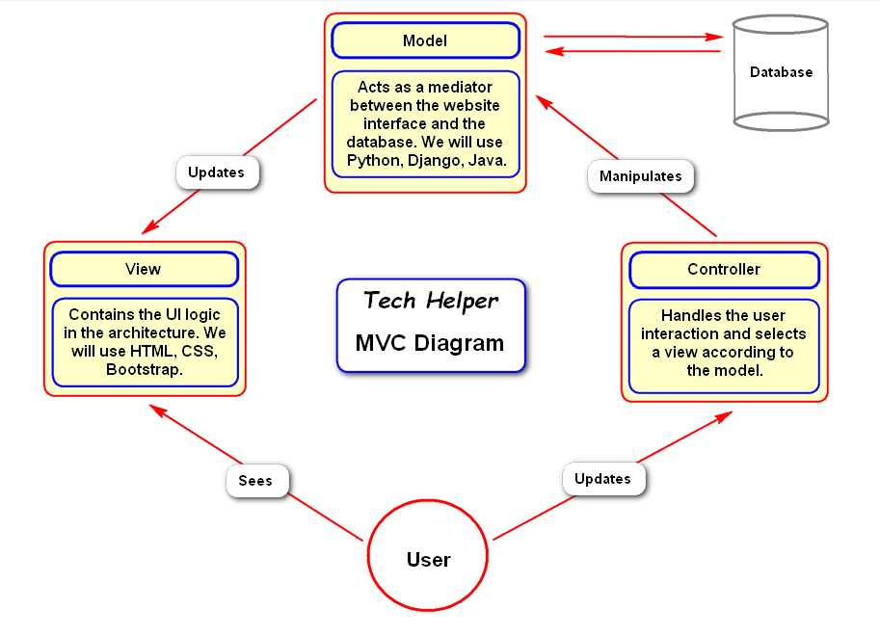

**Functional Requirement:**

* This system will provide question & answer sessions among developers which is an educational service.
* Each user must log in with this personal login credential.
* Each user will get a unique email whenever he created his account in the system.
* Users can find their problem’s solution from the timeline or can ask for a question, or he can answer someone’s question.
* For both asking or answering questions, there will be a matter of points.
* Users can also purchase points if needed.
* There will be a section of the job vacancy or internship.
* There will be a feedback option to contact with the admin panel.
* There will be a service of email notification.

**Non-functional Requirement:**

* We must ensure the security of the whole system first that a non-authenticate user couldn’t access the system’s core features.
* A user can’t change his email for the whole lifetime. He or she can only change the password and the password will store in the database as encrypted.
* If a user provides the wrong password more than three times his account will be disabled, and he must enable his account by a link that will automatically send to his email account.
* We must also ensure that a question quality and admin can ban a user depends on his activities.
* A normal can’t access to the admin panel at any cost.

**Technologies:**

We will use **Python (Django)** to develop this system because python is a very secure language and easy to use. For designing, we will use **HTML, CSS, JavaScript, Bootstrap.** We will use **Xampp Control Panel** as a server because it is a locally created virtual server in which we can easily **Apache** **MySQL** server for our project. Moreover, Xampp is free of cost and easy to use.

**UML Use Case Diagram**

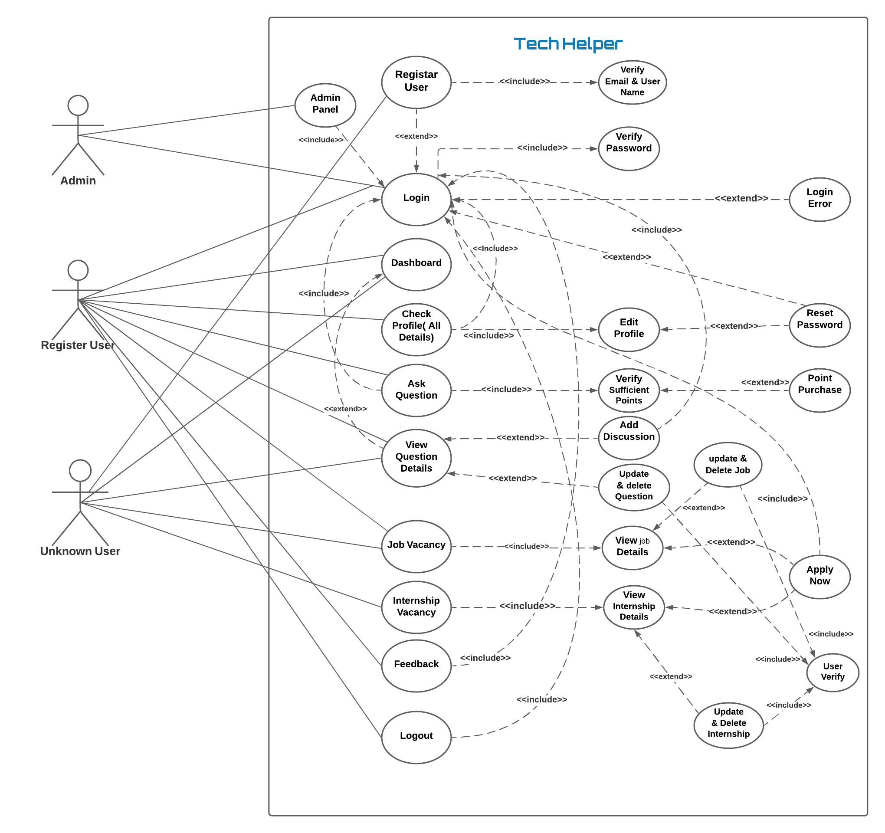

**Fig: UML Use Case Diagram**

***For Better Quality:*** [***link***](https://drive.google.com/file/d/1mTmCmuOa434sXqZfo0JzknsbYPoLkVcc/view?usp=sharing)

**UML Class Diagram**

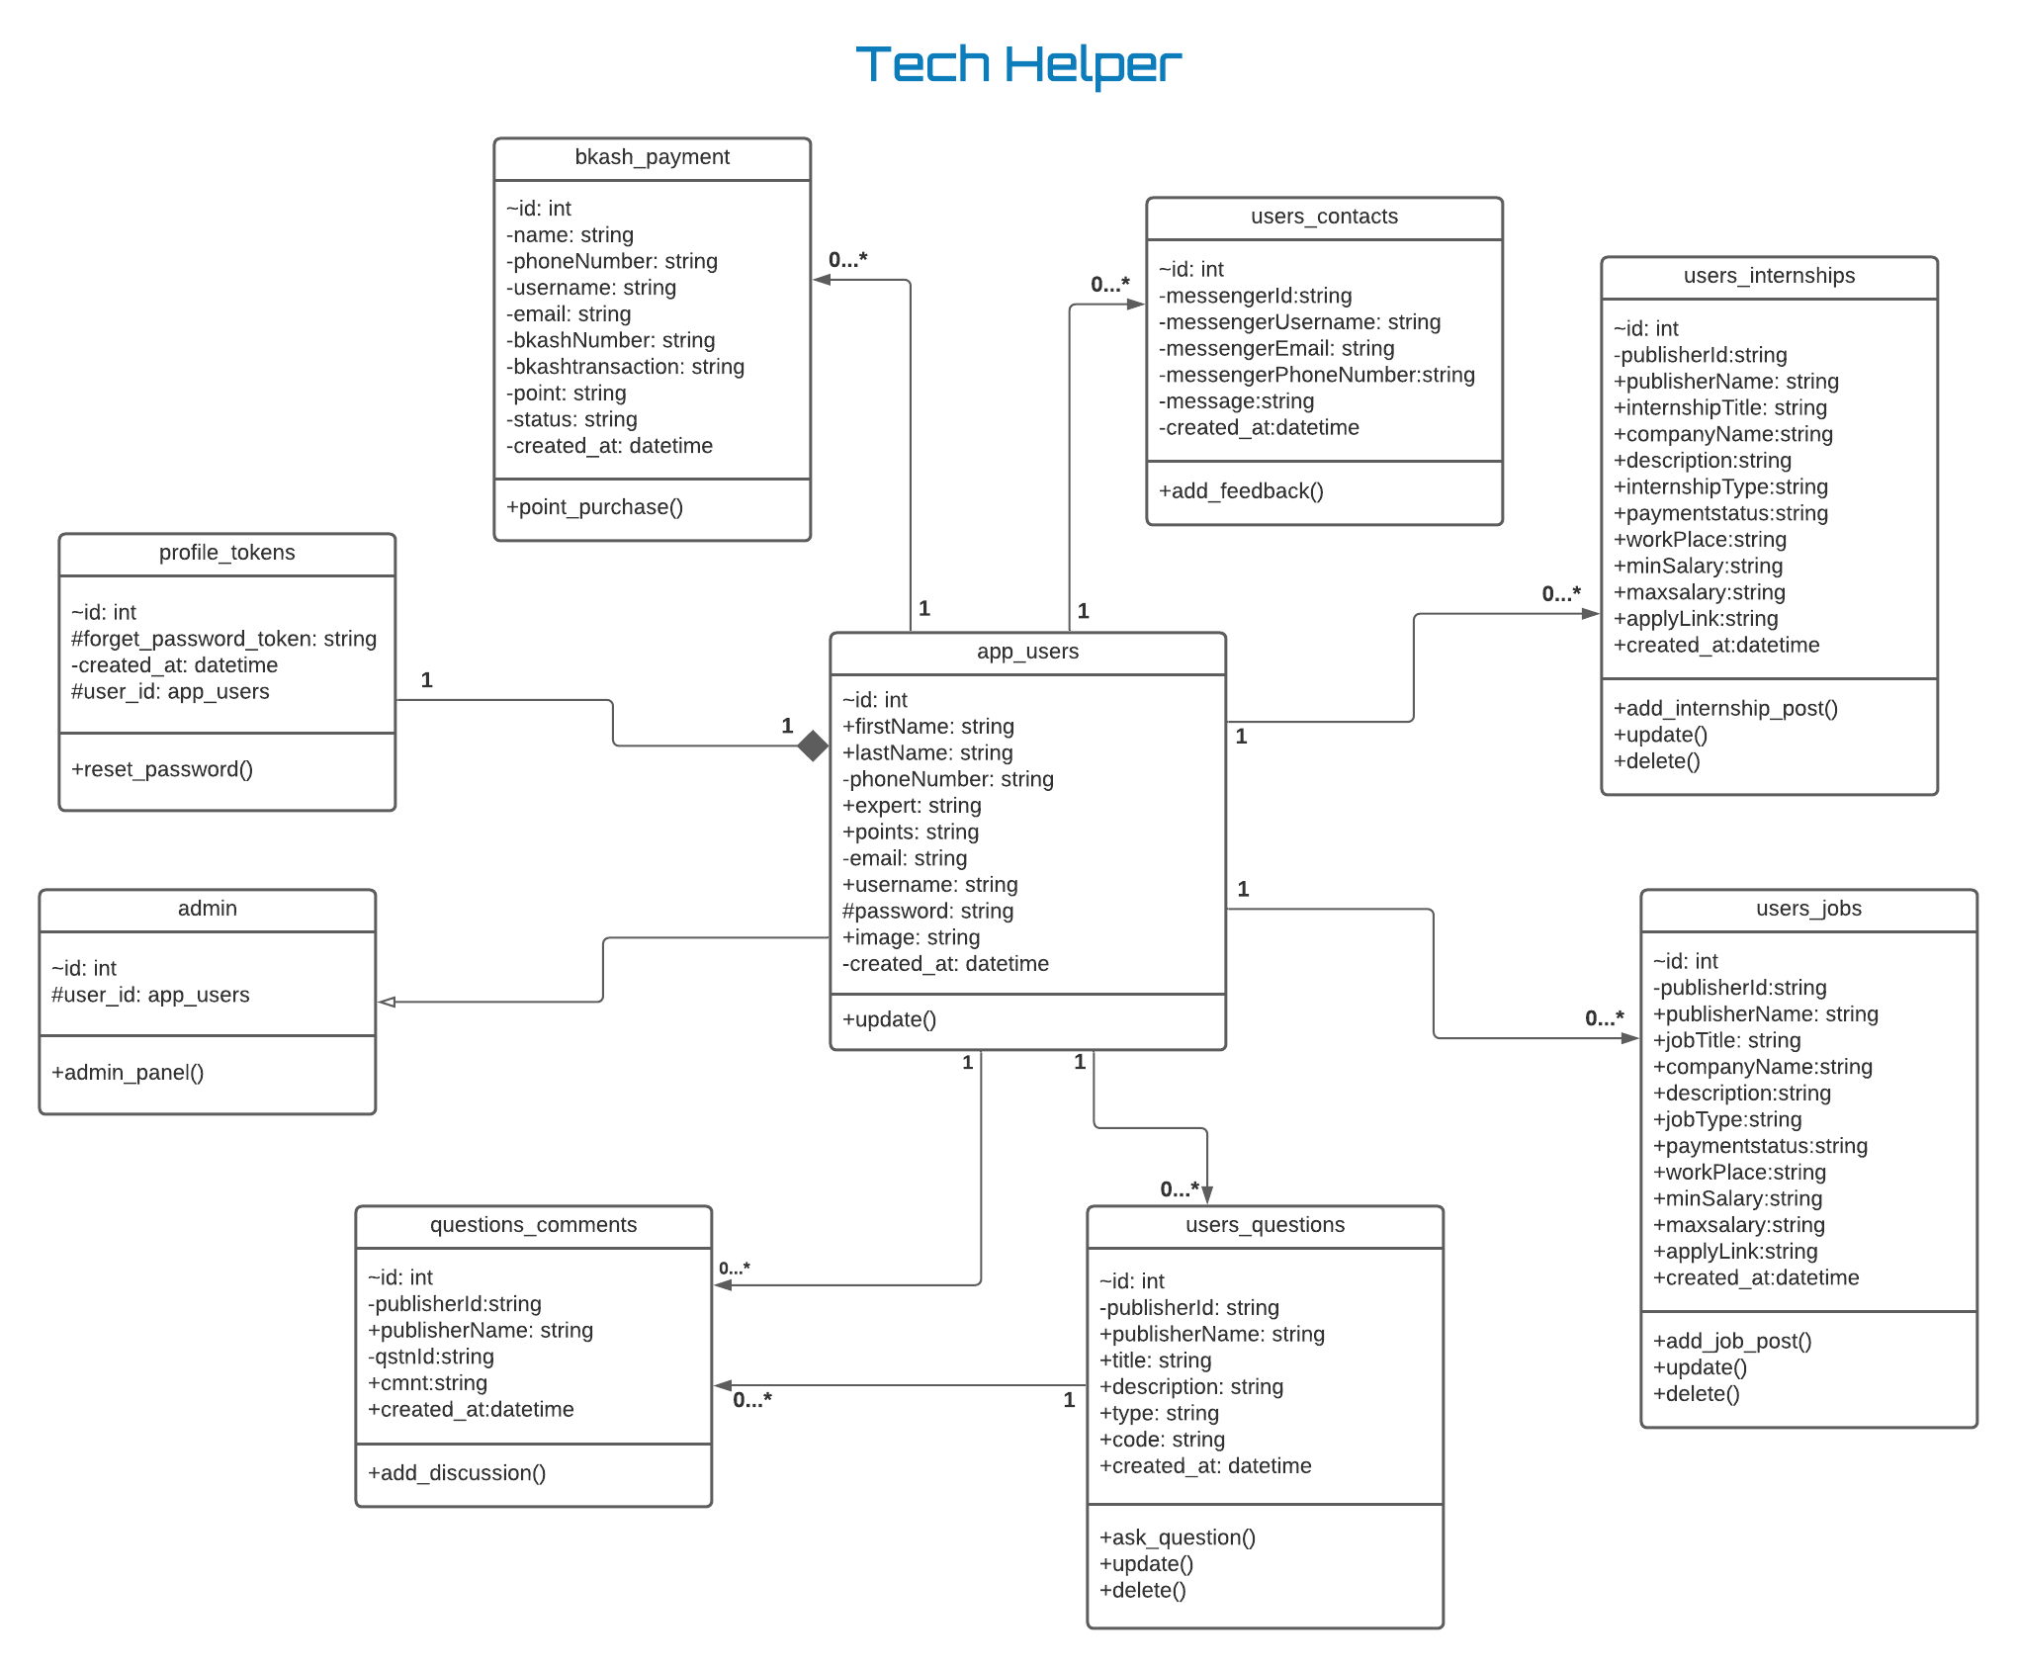

**Fig: UML Class Diagram**

***For Better Quality:*** [***link***](https://drive.google.com/file/d/1cwjj_kdtxdWctOMJsh4HqaVxU-Tw3jDn/view?usp=sharing)

**Activity Diagrams**

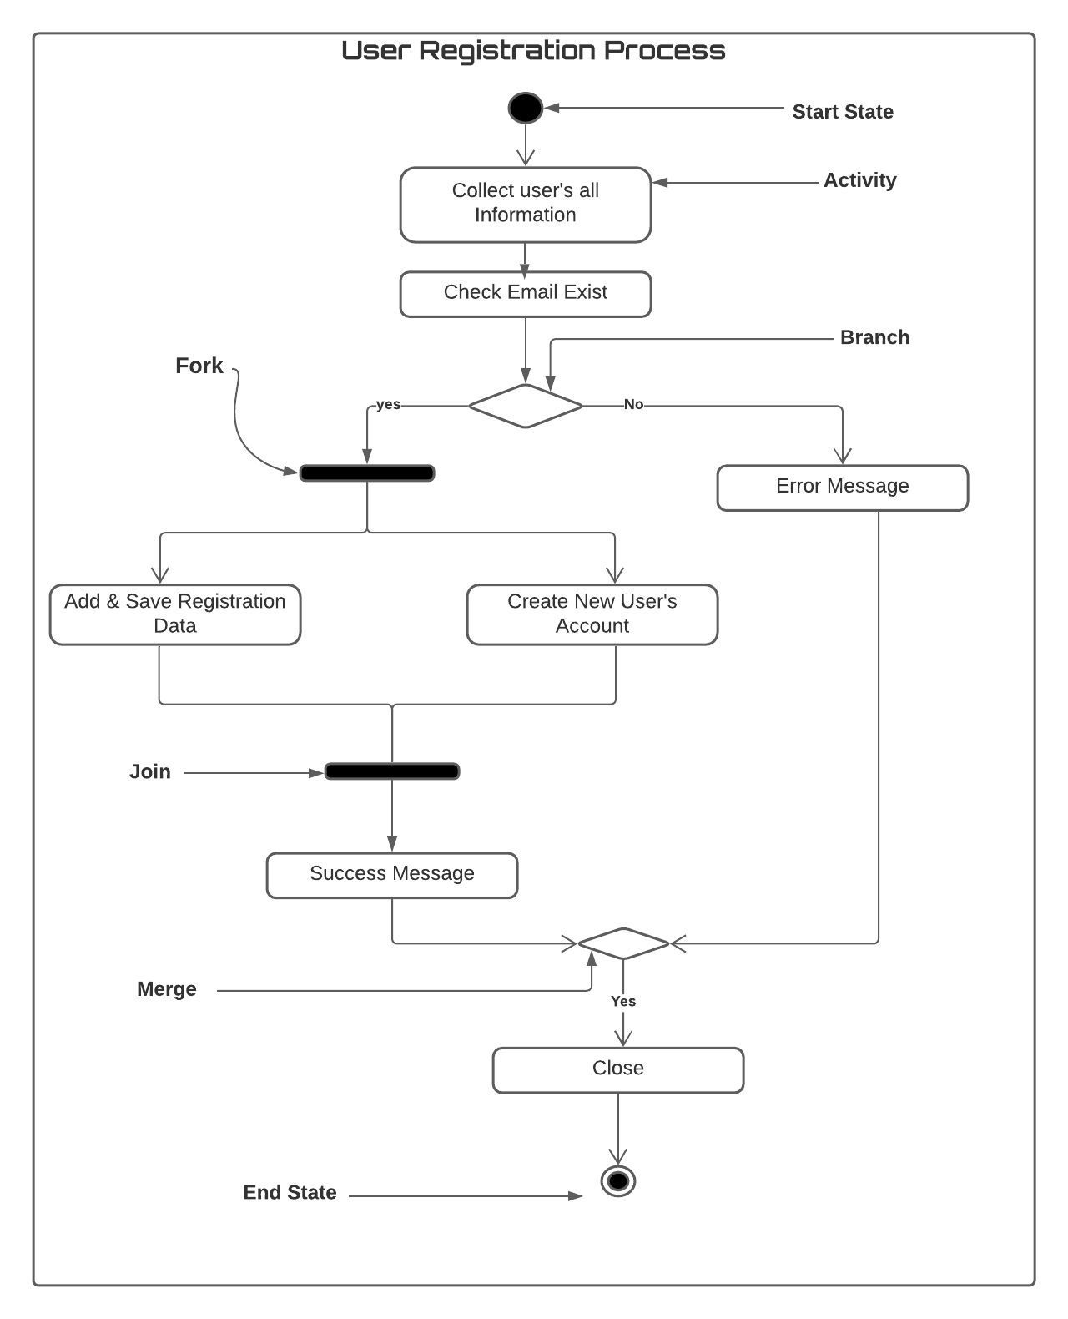

**Fig: Register Process Activity Diagram**

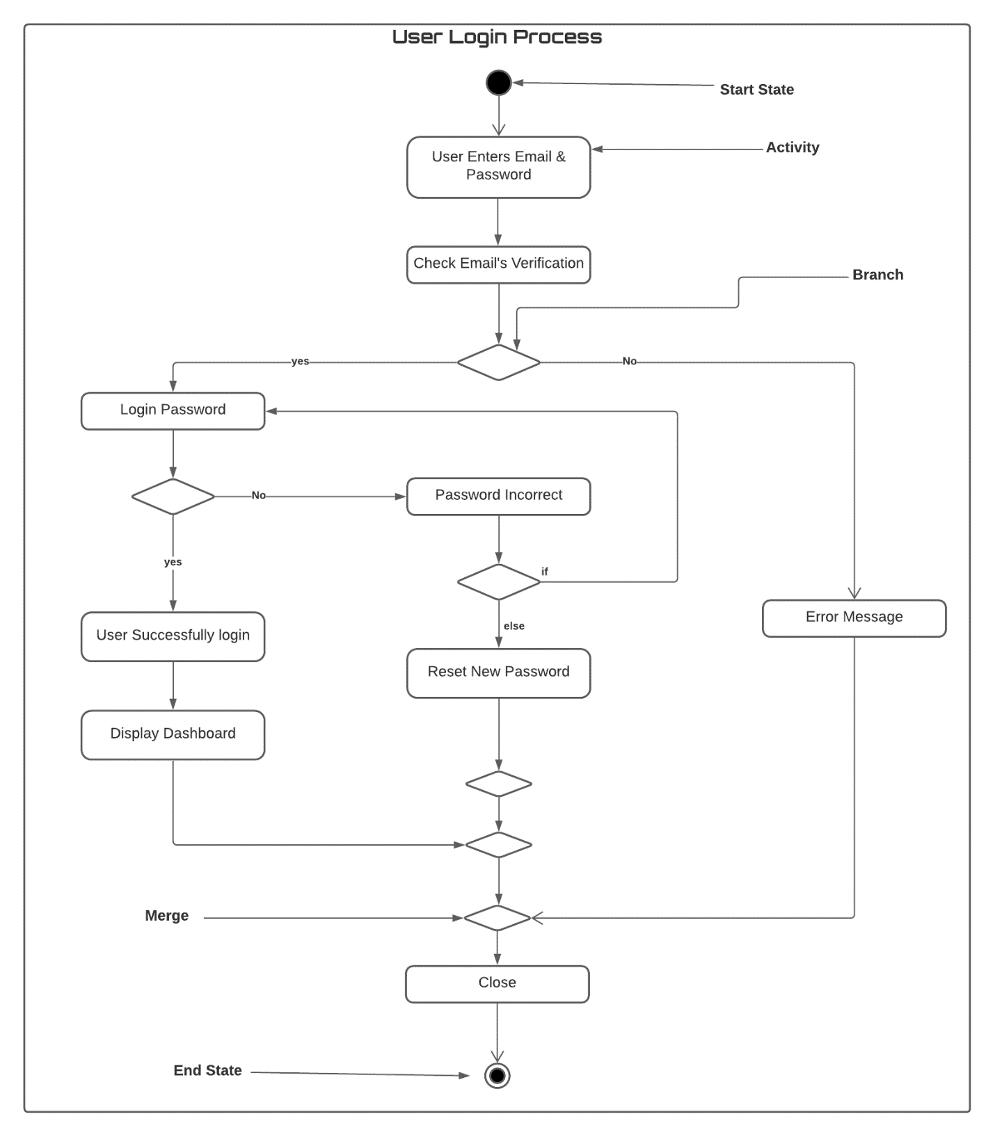

**Fig: Login Process Activity Diagram**

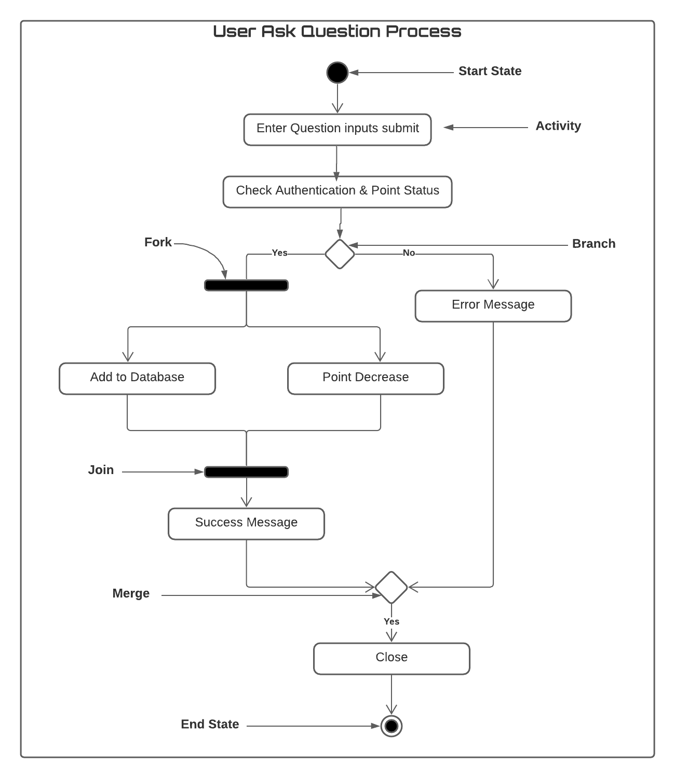 **Fig: Ask Question Process Activity Diagram**

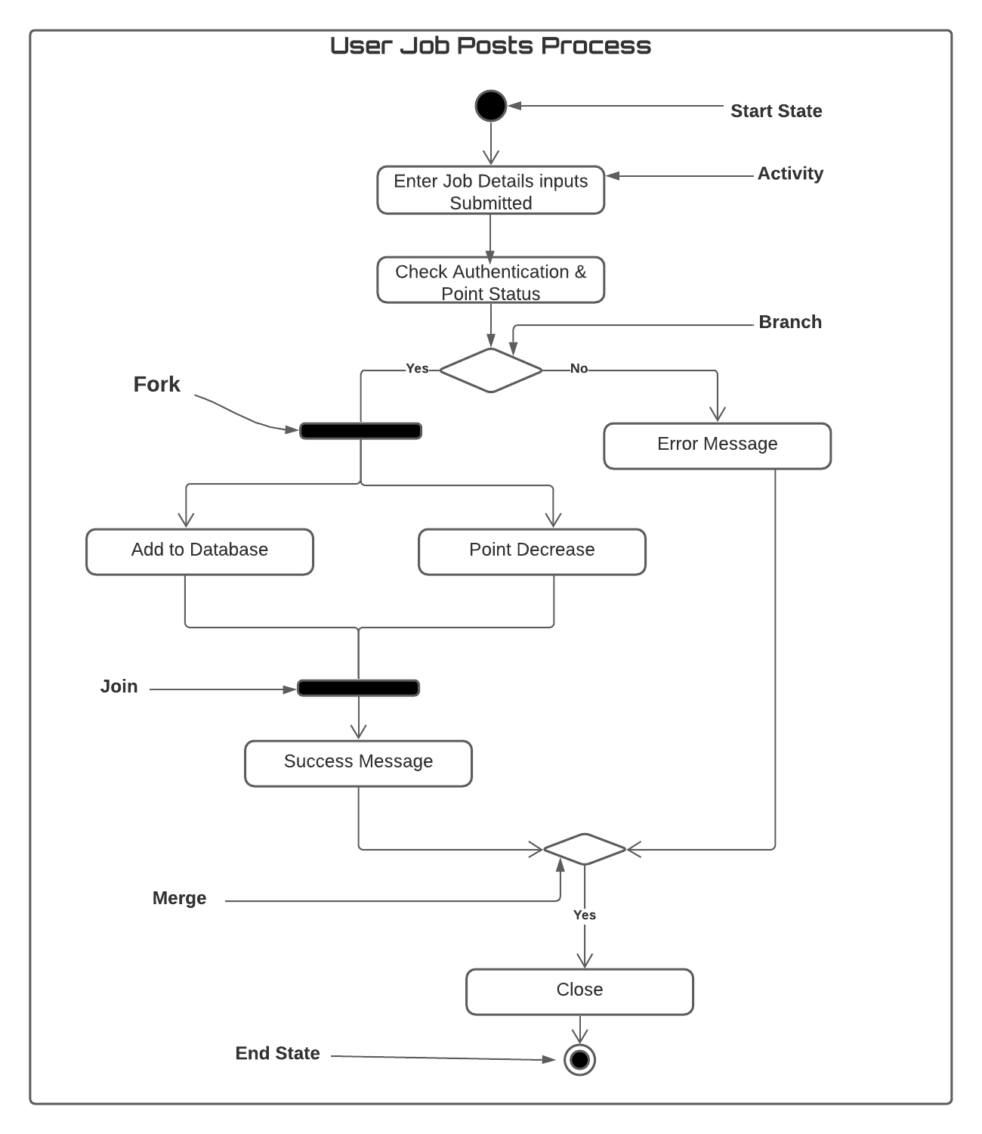

**Fig: Post Job Activity Diagram**

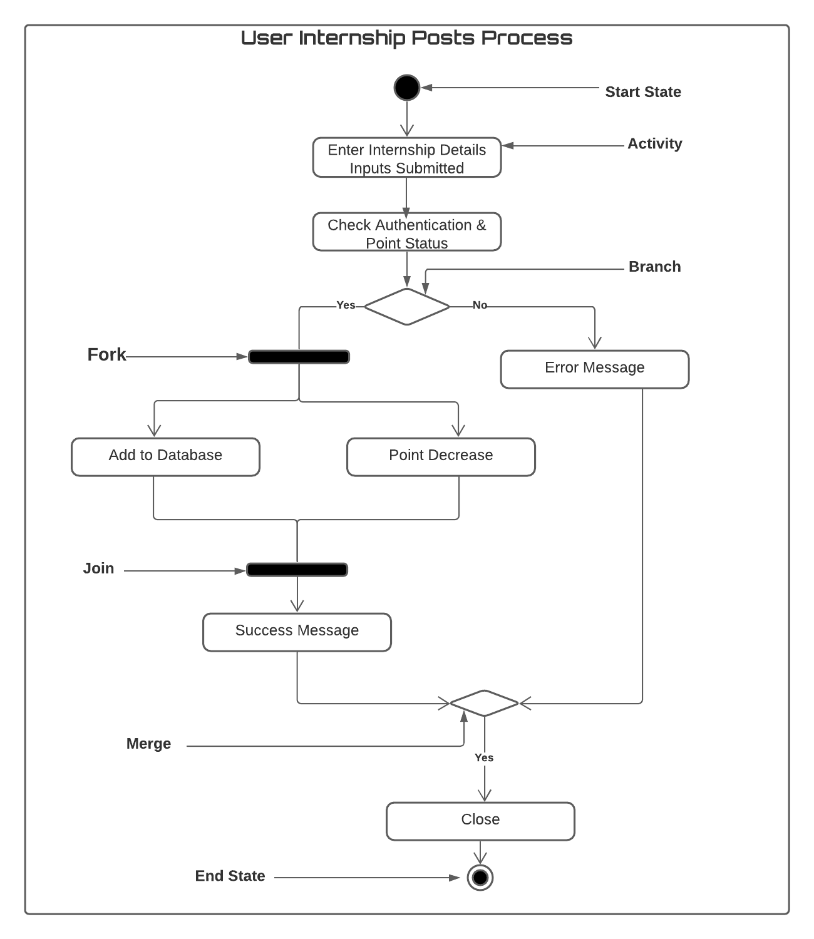

**Fig: Post Internship Process Activity Diagram**

**GUI Screenshots**

